1. The installation of Redhat Enterprise 5.5
1.1 Preparation
- install vmware 6.5
- download vmx file of Redhat Enterprise 5.4 installation

  - Installation
- open a new vmx file(Linux OS) in vmware
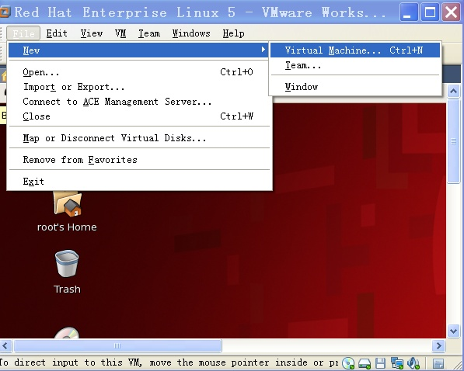
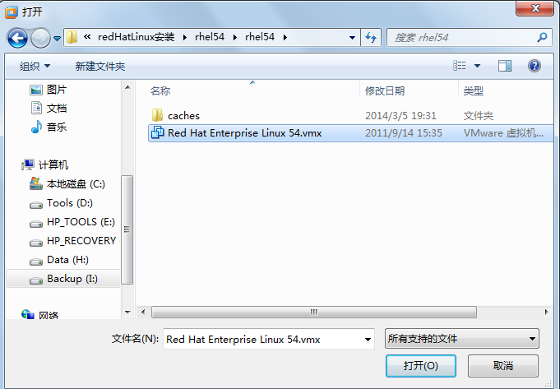
1.3 login
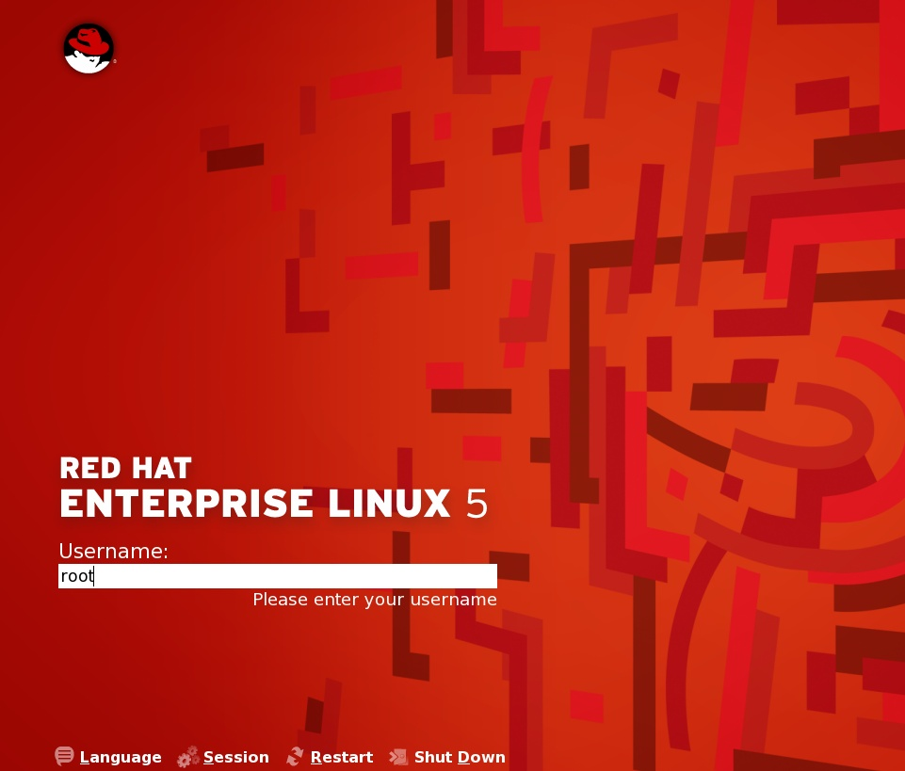
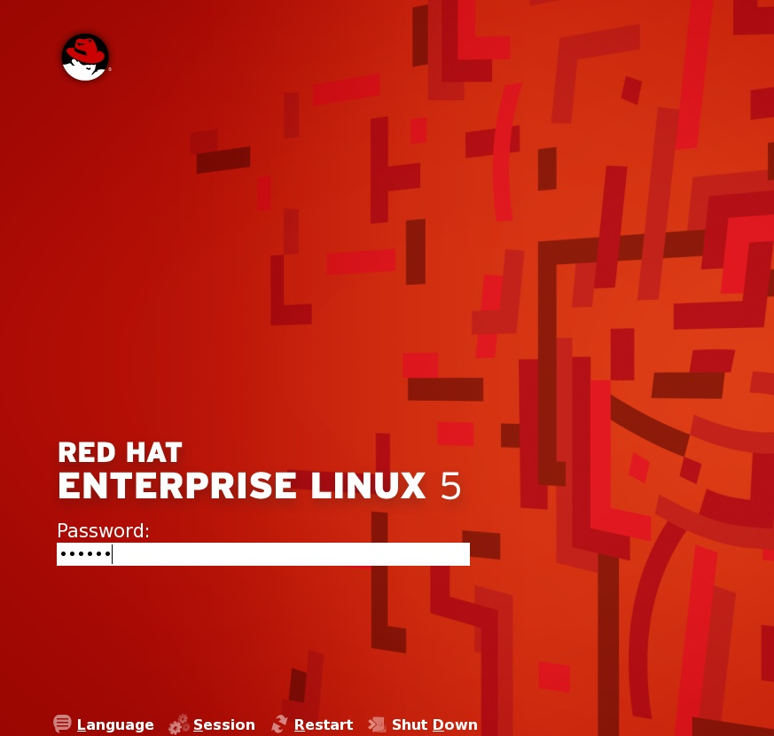
type the password you set in the installation

  - logout or shutdown
